**LAB 2**

**1.1**

CREATE TABLE Airline_info (

airline_id INT PRIMARY KEY,

airline_code VARCHAR(30) NOT NULL,

airline_name VARCHAR(50) NOT NULL,

airline_country VARCHAR(50) NOT NULL,

created_at TIMESTAMP NOT NULL,

updated_at TIMESTAMP NOT NULL,

info VARCHAR(50) NOT NULL

);

CREATE TABLE Airport (

airport_id INT PRIMARY KEY,

airport_name VARCHAR(50) NOT NULL,

country VARCHAR(50) NOT NULL,

state VARCHAR(50) NOT NULL,

city VARCHAR(50) NOT NULL,

created_at TIMESTAMP NOT NULL,

updated_at TIMESTAMP NOT NULL

);

CREATE TABLE Baggage_check (

baggage_check_id INT PRIMARY KEY,

check_result VARCHAR(50) NOT NULL,

created_at TIMESTAMP NOT NULL,

updated_at TIMESTAMP NOT NULL,

booking_id INT NOT NULL,

passenger_id INT NOT NULL

);

CREATE TABLE Baggage (

baggage_id INT PRIMARY KEY,

weight_in_kg DECIMAL(4,2) NOT NULL,

created_at TIMESTAMP NOT NULL,

updated_at TIMESTAMP NOT NULL,

booking_id INT NOT NULL

);

CREATE TABLE Boarding_pass (

boarding_pass_id INT PRIMARY KEY,

booking_id INT NOT NULL,

seat VARCHAR(50) NOT NULL,

boarding_time TIMESTAMP NOT NULL,

created_at TIMESTAMP NOT NULL,

updated_at TIMESTAMP NOT NULL

);

CREATE TABLE Booking_flight (

booking_flight_id INT PRIMARY KEY,

booking_id INT NOT NULL,

flight_id INT NOT NULL,

created_at TIMESTAMP NOT NULL,

updated_at TIMESTAMP NOT NULL

);

CREATE TABLE Booking (

booking_id INT PRIMARY KEY,

flight_id INT NOT NULL,

passenger_id INT NOT NULL,

booking_platform VARCHAR(50) NOT NULL,

created_at TIMESTAMP NOT NULL,

updated_at TIMESTAMP NOT NULL,

status VARCHAR(50) NOT NULL,

price DECIMAL(7,2) NOT NULL

);

CREATE TABLE Flights (

flight_id INT PRIMARY KEY,

sch_departure_time TIMESTAMP NOT NULL,

sch_arrival_time TIMESTAMP NOT NULL,

departing_airport_id INT NOT NULL,

arriving_airport_id INT NOT NULL,

departing_gate VARCHAR(50) NOT NULL,

arriving_gate VARCHAR(50) NOT NULL,

airline_id INT NOT NULL,

act_departure_time TIMESTAMP NOT NULL,

act_arrival_time TIMESTAMP NOT NULL,

created_at TIMESTAMP NOT NULL,

updated_at TIMESTAMP NOT NULL

);

CREATE TABLE Passengers (

passenger_id INT PRIMARY KEY,

first_name VARCHAR(50) NOT NULL,

last_name VARCHAR(50) NOT NULL,

date_of_birth DATE NOT NULL,

gender VARCHAR(50) NOT NULL,

country_of_citizenship VARCHAR(50) NOT NULL,

country_of_residence VARCHAR(50) NOT NULL,

passport_number VARCHAR(20) NOT NULL,

created_at TIMESTAMP NOT NULL,

updated_at TIMESTAMP NOT NULL

);

CREATE TABLE Security_check (

security_check_id INT PRIMARY KEY,

check_result VARCHAR(20) NOT NULL,

created_at TIMESTAMP NOT NULL,

updated_at TIMESTAMP NOT NULL,

passenger_id INT NOT NULL

);

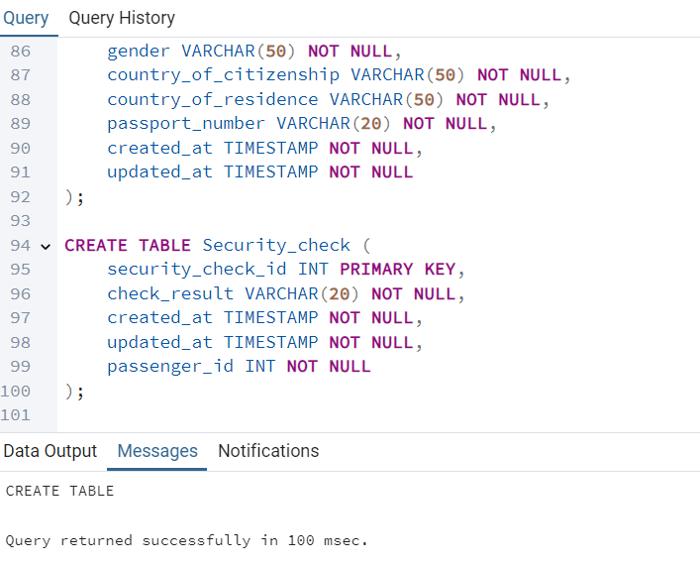

**1.2**

1. 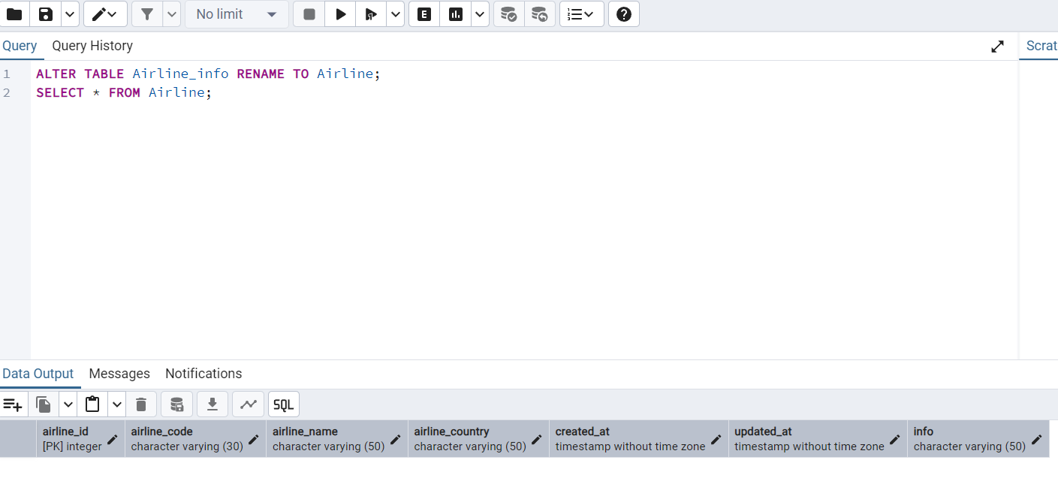

2. 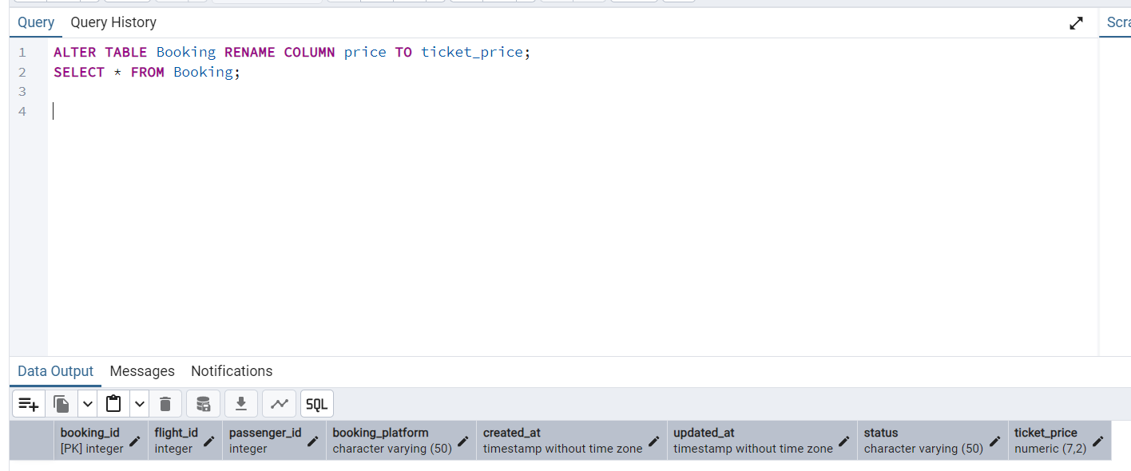

3. 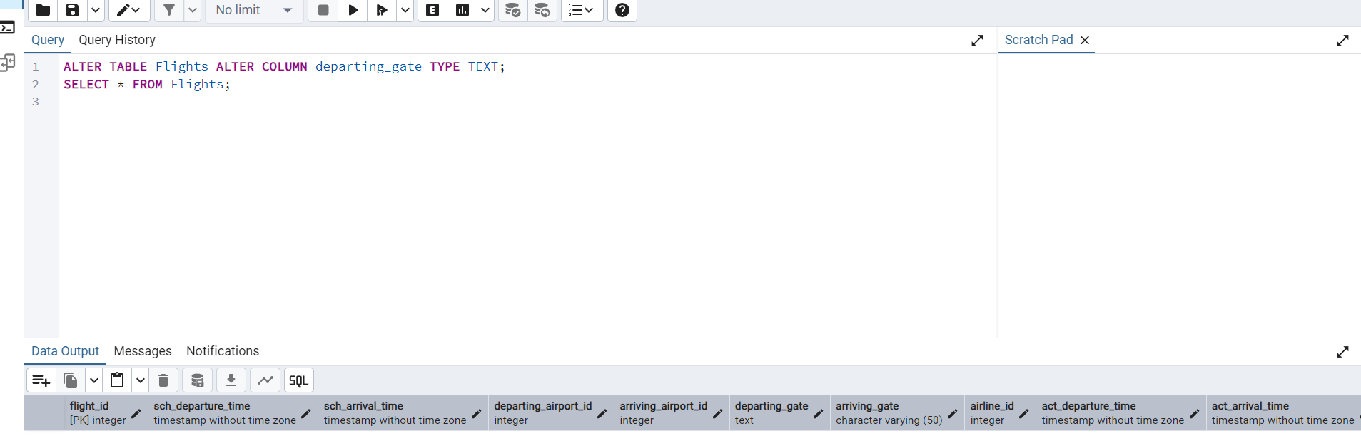

4. 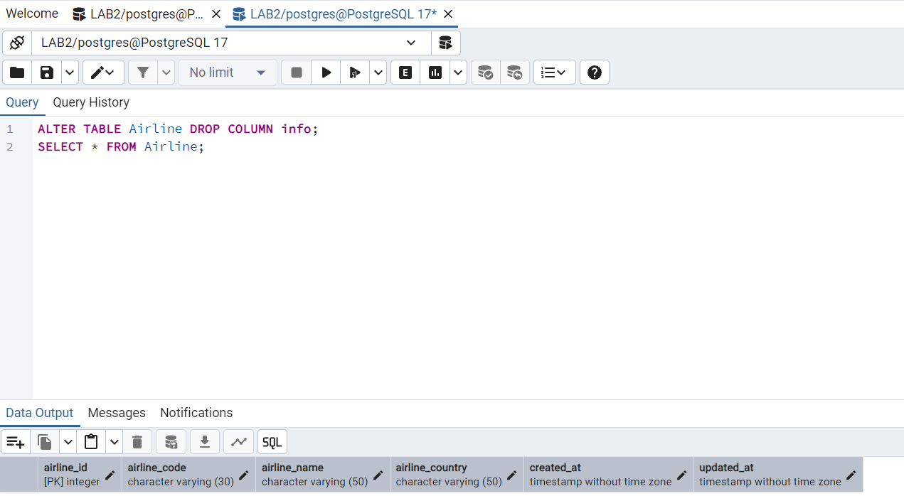

**1.3**

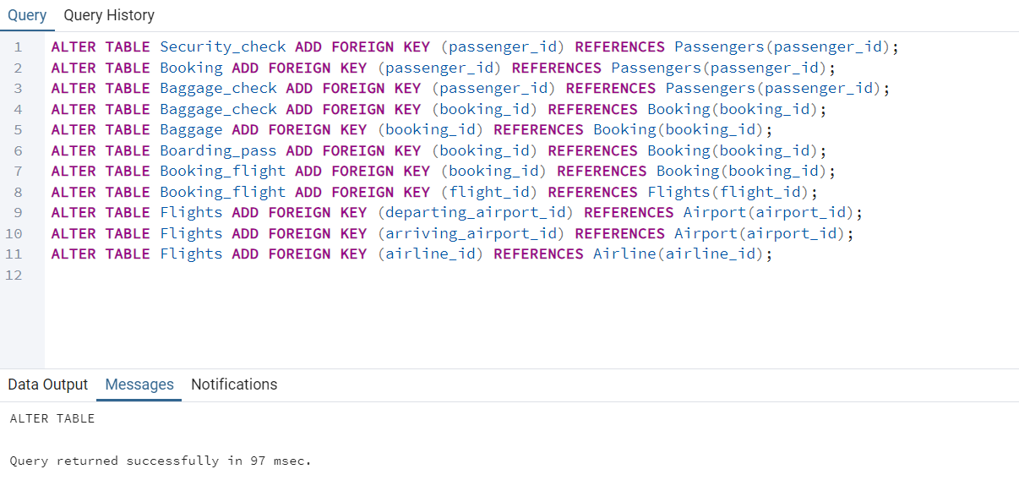

**1.4**

